 | INTERNATIONAL TELECOMMUNICATION UNION  TELECOMMUNICATION  STANDARDIZATION SECTOR  STUDY PERIOD 2017-2020 |  | SG13-TD668/WP1
 |  |  | STUDY GROUP 13
 |  |  | Original: English
Question(s): |  | 17/13 | Virtual, 17 December 2020
TD
Source: |  | Editors
Title: |  | Draft new Recommendation ITU-T Y.CAN-reqts: “Functional requirements of computing-aware networking”
Purpose: |  | Proposal
Contact: |  | Yuexia Fu  China Mobile  P.R. China | Tel: +86 15011564042  E-mail: fuyuexia@chinamobile.com
Contact: |  | Xiaomin Yang  Huawei  P.R. China | E-mail: yangxiaomin@huawei.com
Contact: |  | Jiali You  Institute of Acoustics, Chinese Academy of Sciences (IoA, CAS)  P.R. China | Tel: + 86-10 82547633  E-mail: youjl@dsp.ac.cn

Keywords: | Computing-aware networking; future networks; functional requirements; use cases
Abstract: | This document is the output of draft Recommendation ITU-T Y.CAN-reqts “Functional requirements of computing-aware networking”, resulting from discussion of Q17/13 meeting on 7-17 Dec 2020.

This document is the output of draft Recommendation ITU-T Y.CAN-reqts “Functional requirements of computing-aware networking”, resulting from discussion of Q17/13 meeting on 7-17 Dec 2020.
In the meeting, the following documents are reviewed;

No. | Title | Source | Discussion
C62 | Proposal to update the draft recommendation ITU-T Y.CAN-req: “Functional requirements of computing-aware networking” | China Mobile | Accepted with modifications

In the meeting, the followings were agreed:
- Overall updates including title, scope, work item, and structure of the document.

Future contributions are invited for the following topics with high priority:
- Clause 6 (Introduction and user view) and typical use case for CAN.

Table of Contents
1. Scope 3
2. References 3
3. Definitions 3
3.1. Terms defined elsewhere 3
3.2. Terms defined in this Recommendation 3
4. Abbreviations and acronyms 3
5. Conventions 3
6. Overview of computing-aware networking 4
6.1. Introduction to computing-aware networking 4
6.2. Benefits of computing-aware networking 4
6.3. User view of computing-aware networking 5
7. Functional Requirements for computing-aware networking 5
8.1 Requirements on Computing Power measurement 6
8.2 Requirements on Computing power modeling 6
8.3 Requirements on Computing power broadcasting 6
8.4 Requirements on Computing-aware routing 7
8.5 Requirements on Computing service contract 8
8.6 Requirements on Computing Power OAM 9
8. Security Considerations 9
Appendix I 10
I.1 Use case template 10
I.2 Use case of intelligent load balance across multiple sites in computing-aware networking 10
I.3 Use cases of fault discovery and recovery in computing-aware networking 11
I.4 Use case of cloud VR in computing-aware networking 12
I.5 Use case of connected car in computing-aware networking 13
AppendixⅡ 15

Draft Recommendation ITU-T Y.CAN-reqts
Functional requirements of computing-aware networking
- Scope
This draft Recommendation identifies the functional requirements of computing-aware networking. It describes the following details:
- Overview of computing-aware networking
- Functional requirements of computing-aware networking
- Typical use cases of computing-aware networking
Y.CAN-reqts
- References
Editor’s note: This Clause is for future update according to the progress of the recommendation.
- Definitions
  - Terms defined elsewhere
This Recommendation uses the following terms defined elsewhere:
TBD
  - Terms defined in this Recommendation
This Recommendation defines the following terms:
Editor’s note: Terms will be added according to further update of the texts
- Abbreviations and acronyms
This Recommendation uses the following abbreviations and acronyms:
AI Artificial Intelligence
CAN Computing Aware Networking
MEC Multi-Access Edge Computing
- Conventions
In this Recommendation:
The keywords "is required to" indicate a requirement which must be strictly followed and from which no deviation is permitted, if conformance to this Recommendation is to be claimed.
The keywords "is recommended" indicate a requirement which is recommended but which is not absolutely required. Thus, this requirement need not be present to claim conformance.
The keywords "can optionally" indicate an optional requirement which is permissible, without implying any sense of being recommended. This term is not intended to imply that the vendor's implementation must provide the option, and the feature can be optionally enabled by the network operator/service provider. Rather, it means the vendor may optionally provide the feature and still claim conformance with this Recommendation.

- Overview of computing-aware networking
Editor’s note: Text for this introduction will be considered based on the discussion part of C-732. Contributions are invited.
Editor’s note – The following first text should be elaborated more.
  - Introduction to computing-aware networking
With the development of 5G and cloud computing, the transmission, analysis and storage of massive data pose huge challenges to traditional network and cloud computing, finally driving computing to move down from the cloud to the edge near the data source, forming distributed computing resources in the network. So in future network, there will be multi-level computing resources of centre, edge and terminal side, which are also heterogeneous computing resources for different applications scenarios.
With the trend of computing and network convergence, the computing-aware networking is proposed, based on the ubiquitous network connection and highly-distributed computing resources, it proposes new mechanisms to be aware of the distribution and status of computing resources in network, and combines service orchestration, optimal routing and load balance to schedule the computing and network resources based on the awareness of service request, to improve the efficiency of the computing and network resources.
[Editor’s note on 2020-12-08] What is computing-aware networking? It should be described.
[Editor’s note on 2020-12-08] What is relationship between cloud computing and CAN? The alternative way is to describe the relationship in Appendix.

  - Benefits of computing-aware networking
With the development of edge computing, there will be multiple same services deployed in network, since the limited resources of edge computing, the closest site may be not optimal for client, which cannot guarantee the service quality, so it is required to find a optimal site for client not only based on the distance, but also the real-time status of the edge site.
With the awareness of the status of the edge computing sites and also the central computing sites CAN is able to schedule the service request to the optimal edge site with the optimal path, guaranteeing the service requirements both on network and computing, which will improve the efficiency of network and computing resources, also make sure the user experience.
This sets the fundamental technologies for edge to edge and edge to cloud coordination in future networks including IMT-2020.
[Editor’s note on 2020-12-08] Current texts in clause 6.2 will revisit after discussion on the description of CAN in clause 6.1

  - User view of computing-aware networking
[Editor’s Note on 2020-12-08] It is need to describe the ecosystem of CAN to explain the stakeholder of CAN. Refer user view on Y.3502 or Y.3600 to explain the ecosystem (user view) of cloud computing and big data. With same manner, it is needed to describe ecosystem of CAN in this Recommendation. After the development of user view of CAN, use cases and derived requirements can be developed.

- Functional Requirements for computing-aware networking
Editor’s note – The text should be revisited in detail in the next meeting.
Editor’s note – The requirements have to be numbered and use formal conventions.
[Rapporteur’s proposal] The texts and Figure can be moved to (new) Appendix to explain the comparison and relationship.
The awareness requirements of computing resources in the network include computing power measurement, computing power modelling, and computing power broadcasting.

[Editor’s note on 2020-12-08] Through the use cases, the derived requirements should be developed. After the development of derived requirements in use case, all derived requirements should be analyzed to add the functional requirement in clause 7. Please refer to Y.3531, Y.3530, etc.

- Requirements on Computing Power measurement
From CPU single-core to multi-core, to CPU+GPU+FPGA, various heterogeneous computing resources constitute the resource pool. Facing the heterogeneous computation of diversity, it is necessary to study the representation dimensions of computing resources, and realize the perceptibility and measurability of computing resources.
Another problem is how to measure the required computing resources facing the huge amount of data generated by applications in a unified way?
For example, as Intel calculates, the auto driving of L3 level needs at least 20 teraflops(10 trillion floating-point arithmetic)，while for L4 level and L5 level, the requirements on computing will It go up by orders of magnitude.
- Requirements on Computing power modeling
According to the aforementioned computing resources measurement mechanism, computing resources are required to be modeled and converted into parameters that are understandable for the network. The network node is required to establish the model of currently deployed services and current computing resource performance, and then updates and maintains them in real-time as shown in Figure 6.
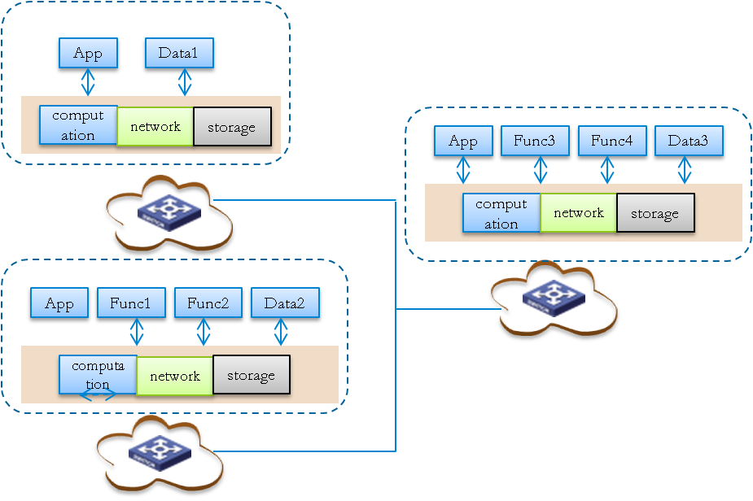
Figure 6. Computing nodes establish the model of services and computing resources

- Requirements on Computing power broadcasting
After measuring and modeling the computing resources in computing nodes, it is required to spread and update the computing service resources in the network so that other nodes in the network can know the specific configuration and real-time status of computing service as shown in Figure 7.

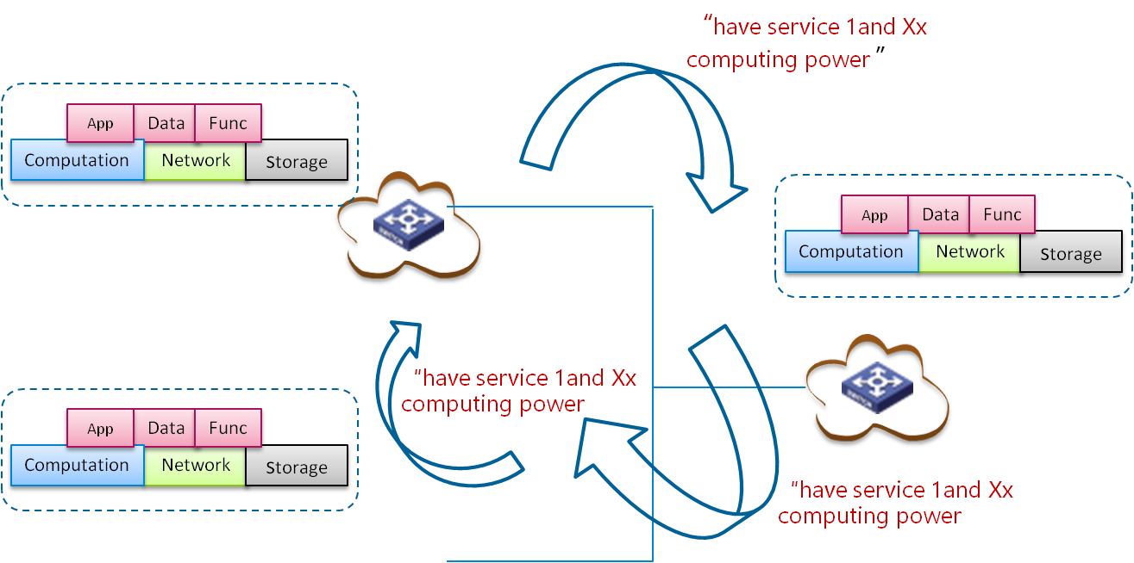
Figure 7.Computing service broadcasting among nodes
- Requirements on Computing-aware routing
Traditional network implements IP connectivity and reachability based on protocols such as BGP and IGP, with only network domain information exchanging in the network. In addition to the network information, the computing service information needs to be injected into the computing-aware networking, As shown in Figure 8, combining the network and computing service information to form unified computing and network convergence metric for route calculation, the computing service, and network status are dynamically updated between edge sites to implement dynamic service scheduling and help users obtain the optimal computing resources.
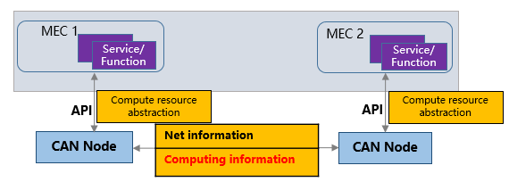
Figure 8. Computing information exchanging in CAN
The computing-aware routing layer includes the abilities of abstracted computing resource discovery, and flexibly scheduling among different computing resource nodes considering the network status and computing service status both. The specific functions include computing resource abstraction and identification, computing-aware route control, network notification of computing service status, computing-aware addressing, routing, and forwarding.
- The computing-aware routing protocol includes abstracted computing resource discovery, and topology and route generation, and healing at the computing resource layer. The topology and route not only include IP reachability, but also include a dynamic status and service availability of computing resources. The healing includes not only route healing, but also re-routing and re-scheduling of computing tasks so that computing task can be executed on appropriate computing service nodes.
- The control-plane routing table is required to contain computing performance and network performance data. Sample service status information to be stored on a CAN edge is shown in Figure 9.

Destination | Computing load | Network cost | Next hop
SID 1 | 3 | 5 | MEC 1
Figure 9. Example of service status information in CAN
- Based on the dynamic computing status and network status, the data plane schedules user requests to the optimal edge site in real-time, that is, the optimal equivalent service instance, to achieve optimal user experience.

The management requirements towards computing resources and related services in the future network include computing service contract and computing power OAM.
With the development of edge computing, the computing resources are extending from center to edge and gradually distributed in the network, which changes the topology of the network and services, the traditional internet is network in the middle, computing and services are peripheries as Figure10, and the network is a pipe to transmit the data without other processing, but in computing aware networking scenarios, computing is embedded in network as Figure 11 and network begin to provide the “connection + computing” service for users, for the aspect of finishing the computing task, the network needs to consider the distance and the status of computing resources.

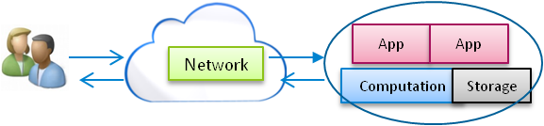
Figure 10. The traditional mode of network

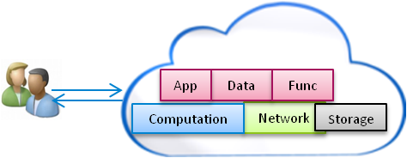
Figure 11. End-to-end network model

Based on the computing power measurement and modeling mechanism, the computing power can be expressed in a unified way, and with the computing power broadcasting, the computing power can be known among other nodes, on the other hand, it is necessary for the network to have OAM on computing power.
- Requirements on Computing service contract
Based on the distributed micro-service architecture, which supports the application to form atomized functional components and algorithm library and will be uniformly scheduled by API Gateway, the API gateway will achieve the atomization algorithm on-demand instantiation, as shown in Figure 12.

Figure 12. API Gateway based on the micro-service
On the other hand, it is necessary for the future network to form the computing service contract model, which will provide the service ability list of network and also the required parameters for the service requester. Based on it, the contract will translate the SLA information to the operational parameter and then pass the parameter to other modules; these parameters will be valuable for computing-aware routing and service dispatch.
- Requirements on Computing Power OAM
After accessing service, the network is also required to monitor the service status, and dispatch the business/service to the optimal site according to the network and computing resources as shown in Figure 13. The initial service site is overloading and the network monitored the abnormal status and then dispatched the service request to another optimal site to guarantee the quality of service.
The OAM also includes account management towards computing power and also includes the fault management of the services and resources.

Figure13. Computing power OAM
What’s more, the computing power OAM includes the charge on computing resources, the charge may include two modes: total amount or usage-based. After the modeling of the computing resources, the resources can be measured, and the network can achieve the charge on the computing resources. The computing aware networking is an open infrastructure to enable massive applications, massive services and massive computing resources. Also, the computing may include the sharing of the computing resources in the smart devices. At the same time, the decentralized trading patterns may be introduced, for example, the smart contract and the blockchain, the user will pay for the usage of the computing resources and services.
- Security Considerations
Editor’s note: This clause will describe the security consideration of CAN.

______________________

Appendix I
Use case of computing-aware networking
(This appendix does not form an integral part of this Recommendation.)
[Contributor’s note] This clause aims to present the use cases of computing-aware networking.

I.1 Use case template
The use cases developed in Appendix I should adopt the following unified format for better readability and convenient material organization.
Table I.1 – Use case template
Title | Note: The title of the use case
Description | Note: Scenario description of the use case
Roles | Note: Roles involved in the use case
Figure (optional) | Note: Figure to explain the use case, but not mandatory
Pre-conditions (optional) | Note: The necessary pre-conditions that should be achieved before starting the use case.
Post-conditions (optional) | Note: The post-condition that will be carried out after the termination of current use case.
Derived requirements | Note: Requirements derived from the use cases, whose detailed description is presented in the dedicated chapter
[Editor’s Note on 2020-12-08] The role in use case should refer the ecosystem in clause 6. Also, the derived requirements should be mentioned the role defined in clause 6. Refer other to Y.3531, 3530, etc.

I.2 Use case of intelligent load balance across multiple sites in computing-aware networking
Table I.2 – Use case of load balance of computing-aware networking
Title | Use case of intelligent load balance across multiple sites
Description | - As shown in Figure, the MEC1, MEC2, and MEC3 broadcast their real-time computing resources status and service deployment information to other edge sites in a network.  - When there are two clients at the same location sending service requests, the client1 sends a request for service 1 and proposes the low latency requirement, the network will comprehensively consider the service deployment status, and begin to select which site among MEC1 and MEC 2 to serve for the client1.  - Both the two edge sites are light-load, but the MEC1 is nearer to the client1, so the traffic from client 1 will be scheduled to MEC1 to meet the latency requirement as shown in Figure 1.  - While for cilent2 requesting for service 2, which are deployed on MEC1 and MEC2, even the MEC1 is nearer to client2, it is busy now and has no enough resources for client2 and cannot guarantee the service quality, so the network will schedule the request to MEC2 to achieve the load balance.  - Besides, there is a load balance between edge and the central cloud. For some service requests which are complex and not time-sensitive, the network can schedule the task to the central cloud to reduce the traffic of edge sites.
Roles | Edge cloud, central cloud, network, client
Figure (optional)
Pre-conditions (optional)
Post-conditions (optional)
Derived requirements | - The edge cloud and central cloud is required to expose their status to the network, including the static information and the dynamic status  - The services are required to deployed on different locations in network  - The client is required to carry the information of location in the service request  - The client is required to carry the service SLA request in the service request  - The network is required to be aware of the status of edge and central cloud and also the status of services deployed on them

I.3 Use cases of fault discovery and recovery in computing-aware networking
Table I.3 – Use case of fault discovery and recovery in computing-aware networking
Title | Use case of fault discovery and recovery in computing-aware networking
Description | - As shown in Figure, different from the traditional scheme that the fault can only be discovered with TCP layer and the status of server cannot be updated timely, with computing-aware networking, the server could update its service and resource information within a specific time.  - So when MEC2 fails accidently, other near sites will receive the abnormal information and then find another available site for the client considering the service requirements, and status of computing resources,  - Then dispatch the service request to the available site MEC3.  - With computing aware networking, the network can timely react to the fault and make sure the service equivalence, finally improving the reliability and stability of the network.  The two general use cases of computing aware networking perform the highly coordination of computing and network resources, and the coordination among edge sites. The status of service deployment and computing resources are available for network, this information can be considered in routing generation and service dispatch to guarantee the service requirements.
Roles | Edge cloud, central cloud, network, client
Figure (optional)
Pre-conditions (optional)
Post-conditions (optional)
Derived requirements | - The edge cloud and central cloud is required to expose the OAM information to the network  - The network is required to react to the fault quickly and assign a new server to client.

I.4 Use case of cloud VR in computing-aware networking
Table I.4 – Use case of cloud VR of computing-aware networking
Title | Use case of cloud VR in computing-aware networking
Description | Cloud VR introduces the concepts and technologies of cloud computing and cloud rendering to VR services. Before being transmitted to user terminal devices through the network, The VR contents would be processed in the cloud, implementing the CODEC, compression and rendering.  Cloud VR services have extremely high requirements for network and computing. For example, entry-level Cloud VR (full-view 8K 2D video) uses a 110-degree FOV for transmission.  - Typical network requirements: 40 Mbps bandwidth, 20 ms RTT, 2.4E-5 packet loss rate;  - Typical computing requirements: 8K H.265 real-time hard decoding, 2K H.264 real-time hard encoding, and multi-channel parallel computing.  Based on the preceding requirements, computing-aware networking performs collaborative optimization on distributed computing resources and network resources. As shown in Figure 3, computing tasks are allocated as follows:  - Central cloud: Multiplexing parallel computing and content generation tasks with heavy computing loads in Cloud VR are deployed on the central cloud.  - Edge cloud: Tasks such as video encoding and decoding and content rendering that have low computing requirements are dynamically offloaded to edge nodes.  Hierarchical offloading of computing tasks improves the utilization of cloud, edge, and network resources, and the user experience of the services, which is a positive impact on the transition from pilot to large-scale deployment of cloud VR.  CAN dispatches the latency-sensitive and medium complexity of computing tasks to the light-load MEC nodes to get the computation result as soon as possible, the more complex computing tasks that are not sensitive to the delay need to be scheduled to the central DC nodes.
Roles
Figure (optional) | 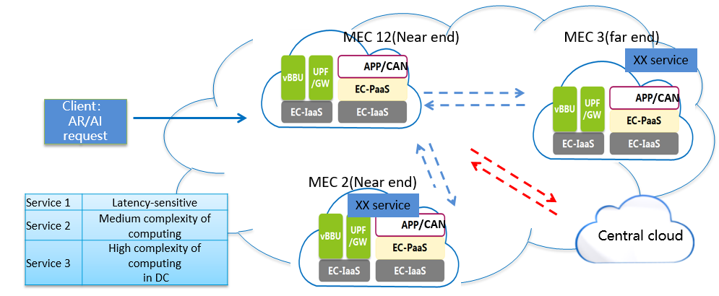
Pre-conditions (optional)
Post-conditions (optional)
Derived requirements | - The network is required to know the service deployment and classify the service request according to the service identity;

I.5 Use case of connected car in computing-aware networking
Table I.5 – Use case of connected car of computing-aware networking
Title | Use case of service management of cloud native PaaS platform
Description | Connected car service scenarios include assisted driving and in-vehicle entertainment services. Computing-aware networking is used for connected car service scheduling and computing resource allocation on the network efficiently and reliably in this case.  As shown in Figure 4, the assisted driving function/service deployed in an edge compute node, to obtain the comprehensive road traffic information around the location of a vehicle, especially for the road traffic condition outside the vehicle due to obstructions, blind spots, etc. and perform unified data processing. And after that CAN would send an alarm signal to a vehicle if there has a （potential）security risk, to assist and keep the vehicle in safe driving.  In the connected car scenario, the computing-aware networking schedules traffic based on service priorities. For example, the computing-aware networking schedules high-priority service traffic like the security risk warning information to the nearest node for computing processing. The latency-insensitive service traffic is scheduled to remote nodes or the cloud for processing, for example, in-vehicle entertainment services.  When the local edge node is overloaded, the assisted safe driving notification may be delayed, which may cause a traffic accident. The computing-aware networking schedules latency-insensitive services such as in-vehicle entertainment from the near-end edge node to other nodes. By reducing the load on the local node and enables low-latency services to be preferentially processed locally, the computing-aware networking ensure the user experience and availability of the assisted driving services for the connected car.  CAN preferentially select the nearest light-heavy MEC1 for processing the delay-sensitive assisted driving service for car 1, when the local node is overloaded, and the delay-insensitive in-vehicle entertainment service of car 2 is dispatched consequently to the remote node MEC3 by CAN.
Roles
Figure (optional) | 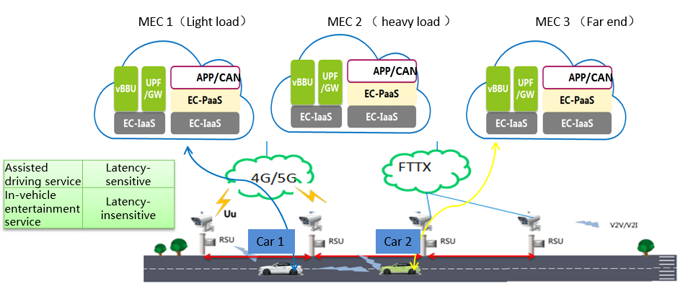
Pre-conditions (optional)
Post-conditions (optional)
Derived requirements

AppendixⅡ
Relationship between cloud computing and computing-aware networking
It is predicted by Gartner that by 2025, more than 75% of the computing data needs to be analyzed, processed, and stored at the edges. In this trend, the industry faces a strategic transformation from "device, PIPE, and cloud" to” device, EDGE, and cloud", with the growth of storage capability and computing capability is far beyond the network bandwidth, the trend of digital transformation brings a challenge to the cloud computing and current network, which truly promotes computing resources extending from the cloud to edge, as shown in figure 1.
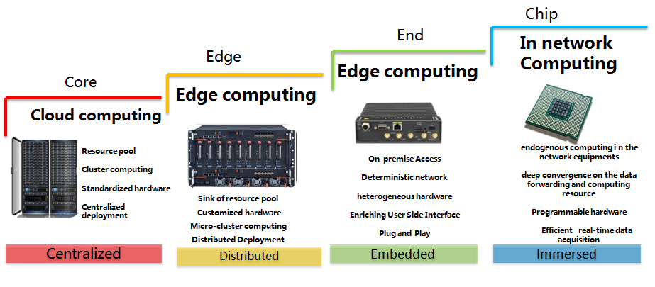
Figure 1. The evolution trend of computing in the network
On the other hand, from tens of billions intelligent terminals to one billion home gateways, to thousands of base stations with computing power which are brought by MEC, to hundreds of Cloud CO brought by NFV, and to dozens of large Cloud DC, which form massive ubiquitous computing force from everywhere accessing to the Internet, finally form the deep integration of computing and network. Combined with artificial intelligence and other emerging technologies, telecom operators are building an end-to-end computing plane with edge computing on top of the network plane, forming the fully coverage of computing resources as shown in Fig2.
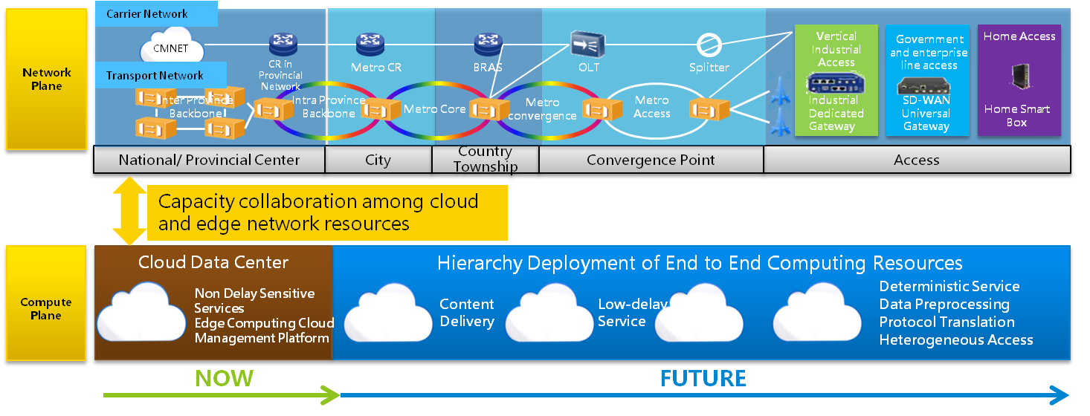
Figure 2.Multi-access computing plane in network
There are several issues associated with edge computing not addressed in the existing edge computing related organizations, including: 1) lack of scalability at single edge site; 2) lack of coordination between multiple sites; 3）lack of coordination between network resources and computing resources.
The first issue is lack of scalability at single edge site. As edge site’s location is getting closer to user, the processing power and storage capacity becomes limited due to space and other environmental constraints. However, the services requirements including computing resource requirements cannot be predicted, which results the quality of service cannot be guaranteed well by single edge site with limited resources.
The second issue is lack of coordination between multiple sites, including low statistical multiplexing of computing resources. In addition to the limited resources in each edge site, the static deployment of MEC making it impossible to reuse the resources between multiple sites, further resulting the low resource utilization; what’s more worse is the tidal effect of edge computing is more serious than cloud computing, which requires the dynamic and real-time resource allocation. There is a wide gap between the dynamic requirements and static, isolated resources allocation of multiple edge sites.
The third issue is the lack of coordination between the network and computing resources. The emerging services propose requirements towards both network and computing, which also affect each other. With the convergence of network and computing resources, we need not only ensuring the reachability of IP addresses, but also the availability and QoS of computing resources, only in this way can we support traffic scheduling based on network resources and computing resources coordination. So we need to build one operating system to performing the computing resources scheduling for the coordination.
Under the above trend and arising problems, new business opportunity for Telco ICT transformation is emerging. For telecomm operators, firstly, there is a unique value that only operators have already owned a large number of edge sites; furthermore, with the coordination between multiple sites to achieve dynamic resource allocation, operators will be able to transform to ICT services, which means that transform business offering from bandwidth towards network connection and related computing and storage. On the other hand, for OTT, internet companies will be able to shift to light asset mode through edge sharing from Telco, save Asset Investment and O&M Costs of massive distributed edge nodes.
So in the future network, considering the significant trend of network and computing convergence evolution, and the challenges arising in edge computing, it is necessary to be aware of the computing status not only the network link status, and based on the computing information, the service deployment and service scheduling could be done on demand. And the computing information includes the static information of computing resources/computing services, such as location, type and amount of computing resources etc, and dynamic information of computing resources/computing services, such as utilization rate, response time etc.
From the discussion above, for CAN, there exists an urgent need to first describe the corresponding technical requirements and principles towards future network, and what’s more, providing the application scenarios of CAN.

__________________

