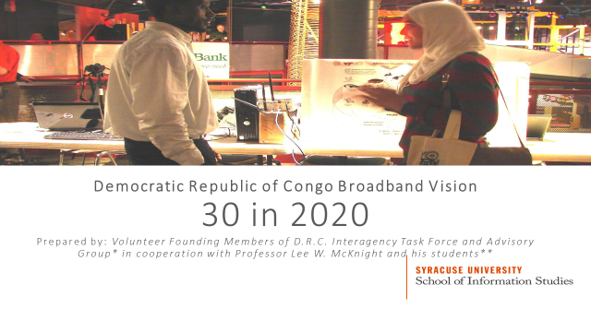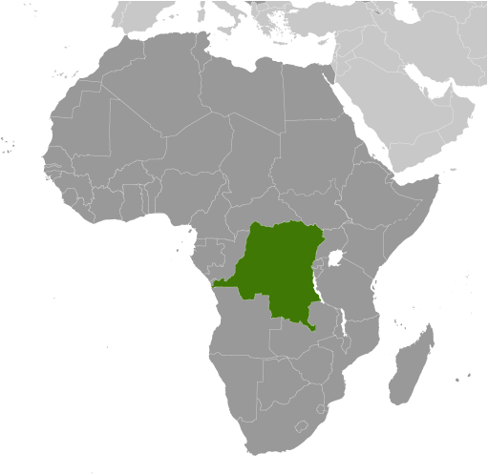

April 4, 2017

Executive Summary
- An innovative education-first strategy enabling the Democratic Republic of Congo to benefit from 30% Internet penetration by 2020 is envisioned.
  - Internet penetration in the DRC presently is 4%.
- In 2017, social emergency preparedness education and training, initially for school children living near the Mt. Nyiragongo volcano, will be offered.
  - These OPEN (One Planet Education Network) trials will be undertaken in cooperation with Goma Volcano Observatory, ministries, provincial government, schools, UNESCO, entrepreneurial groups, and community residents.
  - Internet Backpacks from OPEN partner WGC enable participating school communities to communicate with educators, first responders, public officials, and friends and family locally, regionally, and globally.
    - Whether the DRC schools are otherwise on or off the Internet, cloud to edge education services and social emergency response are now possible.
- Also in 2017, four DRC Provinces will designate themselves Innovation Zones.
  - A Broadband Readiness Checklist completed by the Provincial government and regional IATAG partners will confirm readiness.
  - As Provinces and Ministries accelerate innovation, new entrants, mobile and utility providers will develop solutions advancing DRC Internet growth.
  - New spectrum, Tower, fiber network, data center, microgrid energy system, security, and other resource sharing policies will enable rapid, cost effective growth in Internet accessibility.
  - Support of IATAG partners for wireless, fiber, and electrical utility infrastructure build-outs will progress through 2018. Internet backpacks for emergency and educational use will be provided to participating schools in the four Provinces otherwise off the grid.
    - The establishment of an annual series of DRC Internet Forum (DRCIF) meetings will facilitate continuous multi-stakeholder dialogue.
- To achieve these goals, a three step process is outlined in this ‘30 in 2020. DRC Broadband Vision’ statement.
  - Step One: Share and refine the Vision.
  - Step Two: Identify and Remove Barriers to Internet Growth.
  - Step Three: Work with Innovation Zone Provinces, business partners, and community groups to achieve the 30 in 2020 Vision.
- Interested groups are encouraged to join us in this effort. More information is at https://iatag.org To join the IATAG, please contact the Co-coordinators:
    - Eric Bidong, member, IATAG and Congo Entrepreneurship Gate, tel.: +243 974851473, email: erbid49@gmail.com
    - Arsene Tungali, member, IATAG, Rudi International, and IGC: tel.: +243 993810967, email: arsenebaguma@gmail.com
Introduction
The Problem and the Objective
Internet penetration in the Democratic Republic of Congo (DRC) is 4%. According to Radio Okapi, the high costs of services and the lack of infrastructure block most people from accessing the Internet. The high Internet costs are due to the high cost of satellite bandwidth use, which raises Internet providers operating costs. Low Internet penetration in the D.R.C. is a brake on the development of this country, experts in the sector confirm. This damages both the economy and society, and is especially dangerous in case of emergency. The objective of the Interagency Task Force and Advisory Group is to support the D.R.C. achieving 30% penetration as soon as 2020.
Purpose
The purpose of this memo is to provide a Vision to suggest how this Interagency Task Force and Advisory Group (IATAG) can help catalyze interagency and civil society in cooperation with industry, government and NGO investment to enable D.R.C. Internet penetration to exceed 30% as soon as possible. The target of 30% in 2020 is very ambitious. We know that; and we know it is not impossible. The economic and social benefits are obvious as a more connected and wealthier D.R.C. creates more economic opportunities for citizens and investors, improves health and well-being, and improves the functioning of the public and private sectors.
Methods
The first step is to elaborate this Vision statement draft, and share with a wider group of public agencies invited to join in this effort. In addition, additional advisory group members will be invited to participate from organizations such as D.R.C. universities, schools and learning centers as well as firms, and international colleagues will be invited to comment on and contribute to the draft documents and plans. No public funds will be spent or committed at this stage of initial multi-stakeholder dialogue. An Interagency Task Force and Advisory Group website is being established. Its purpose is to share and refine the BroadbandDRCVision, and continue to expand the number of DRC citizens and government agencies engaged in shaping future DRC broadband Internet services. See: www.iatag.org
The second step is to identify key inhibitors and barriers, which must be removed or reformed if the DRC Broadband Vision is to be realized. We recognize that identifying inhibitors and barriers may produce a long list. In addition, we recognize challenges will vary both between and within the Provinces of the Democratic Republic of Congo.
To obtain a realistic view of current conditions and critical barriers, infrastructure providers of telecommunications and energy, and their business, residential and public sector customers must be encouraged to contribute to this dialogue, along with potential new market entrants. Investors and industry partners, who affirm they would contribute if identified barriers were removed, will be especially encouraged to participate in this multi-stakeholder process.
The Interagency Task Force and Advisory Group carefully weighing priorities and critical obstacles will be key. Also important will be identifying areas especially ripe for early success to build momentum for the national effort. Of course, government and private sector partners in the multi-stakeholder process remain free to serve their own interests and needs.
International agencies such as UNESCO, the World Bank, and international non-governmental organizations will be invited to offer financial and technical support, and identify their own bandwidth needs, and projected demand, for advanced broadband Internet in the DRC, if it were available. Aggregating demand by supporting inter-city hybrid heterogeneous (fiber, wireless, and satellite, as well as off-grid solutions) networks will be key to enabling sustainable, rapid growth in connectivity and Internet access. Therefore, experienced operators and advanced new entrants promising beyond 4G multi-services will be invited to engage.
The power needs of the telecommunications infrastructure may be met in part through solar, but that must also be planned and invested in, for the Vision to be realized. Therefore, experienced actors who have helped advance the utility infrastructure elsewhere in Africa are joining the Advisory Group.
A key element of this process will be establishing an annual series of DRC Internet Forum meetings, to facilitate continuous multi-stakeholder dialogue. This is essential for the 30 in 2020 objective to be reached. Interagency Task Force and Advisory Group members have experience establishing similar fora at the international, regional and national level. These include contributing to theInternet Governance Caucus (IGC); the United Nations Internet Governance Forum (IGF); the Dynamic Coalition on Internet Rights and Principles (DCIRP); Caribbean Internet Forum; Internet Governance Forum USA; ICANN; the Civil Society Information Society Advisory Committee (CSISAC) of the Organization for Economic Cooperation and Development (OECD), and Internet Society (ISOC), as well as technical and industry standards organizations. As appropriate, individuals affiliated with these multi-stakeholder organizations and coalitions will be invited to engage and contribute to the Democratic Republic of Congo attaining its 30 in 2020 objective for its citizens and the global community’s benefit.
A third step is to identify several Provinces whose Governors and citizens may be prepared to commit to supporting the Vision. The proof of their commitment is their formally volunteering their Provinces as Innovation Zones. Both government and civil society must be prepared to take practical and difficult actions to make the plan implementable. Tentatively, this Interagency Task Force and Advisory Group has identified North and South Kivu, Kinshasa, and Bunia as Provinces to begin dialogue with their Governors and community groups. To ascertain if both government and civil society may commit to supporting the process and actions needed to realize the Vision, the IATAG will facilitate a series of public fora and hold open meetings in interested Provinces.
It goes without saying that Provinces volunteering to be selected as prospective Innovation Zones must be willing to do more than – volunteer. The IATAG is developing a checklist and brief questionnaire for submission by the Governor of interested Provinces, with indications of broad support by local officials, university and school leaders, businesses, and community organizations. It also goes without saying that guidance and feedback from the Ministries of Education, Planning, and Telecommunications will be needed. Regulations, municipal codes and laws may need to be amended for this process to succeed in realizing the 30 in 2020 Vision. (The powers of all agencies are of course unchanged; but the process and speed of decision-making likely will need changed expectations so private sector funds can be committed by 2018.)
Both building code and infrastructure planning modernization may be needed, for example to permit competing firms to share network infrastructure resources as they feel is most beneficial to themselves and their customers. Infrastructure build-outs including backhaul and fronthaul, tower and fiber sharing wherever possible to minimize costs and maximize benefits is to be encouraged. Both licensed and unlicensed spectrum use and planning may need to be reformed for the Vision to be realized, – at least or especially for allocation of bandwidth to new entrant and incumbent operators, and for unlicensed services. Finally, both equipment and service import and export procedures must be opened to the recognition that a great deal of advanced equipment will need to be imported. Opportunities for exports of products and services from the DRC will also be created of course by the combination and integration of diverse technologies and services from domestic and international suppliers to meet the needs of the DRC.
Schools and other public agency ‘anchor tenants’ confirming their interest in improved Internet access to help cost-justify infrastructure investment may accelerate commercial willingness to co-invest in the Vision, and the emerging market opportunities in the Innovation Zone Provinces. Likewise, businesses in Innovation Zone Provinces confirming their willingness to subscribe to additional telecommunications, cloud and Internet of Things services if available in the region will be a critical factor incenting new investment in advanced broadband Internet in the DRC.
Incumbent telecommunications operators identifying what they perceive to be the key challenges in the region is also critical input for the Task Force to consider. For example, it may be that mobile backhaul is the top obstacle, as it was in Ugandan regions where Facebook co-invested in 2017 with two operators to remove that barrier. See: https://code.facebook.com/posts/1642803246023947/airtel-and-bcs-with-support-from-facebook-to-build-shared-fiber-backhaul-connectivity-in-uganda/
The virtuous circle of private sector actors encouraged by reformed government innovation policies and engaged community groups inviting change will risk investment in advanced wireless, mobile and fiber infrastructure in the DRC as soon as possible. This can increase access and can lower costs for everyone while improving quality and variety of services far beyond 4G. These include innovative hybrid heterogeneous software-defined and virtualized networks offering cloud services across wireless grids for the Internet of Things with edgeware.
Once these three steps have been taken, investors in new infrastructure will enable providers to offer new broadband Internet services and new wireless grid for Internet of Things technology (5G+), and devices for on and off-grid use will be widely available in the initial 1 –4 territories or Provinces at affordable prices.
This process of community, industry and government can be adopted or modified based on lessons learned so that D.R.C. citizens nationwide share in the benefits of the D.R.C.’s 30 in 2020 Broadband Vision. We also aim to set a positive example for other African nations seeking to overcome their own challenges and obstacles towards advancement to a 5G + future.

Timeline
No | Activities | Months
 |  | 1st | 2nd | 3rd | 4th | 5th | 6th
1 | Elaborate this draft Vision statement
2 | 1st Edition of the full first draft
3 | Identify key inhibitors, define strategies to remove barriers
4 | Identify two to four Provinces whose Governors commit to supporting the Vision; begin discussions in several
5 | Adopt or modify actions in initial territories or provinces based on community, business, government, and investor feedback. Sustained government support for attaining the 30 in 2020 goal can incent fiber, wireless, utility, and cloud technology and service providers to co-invest with D.R.C. communities, international organizations and African businesses in the Vision.

Demonstration and Innovation Zones for Education, Civil Projects & Internet of Things
We propose that the Planning Ministry, Education Ministry, and the Government of the Democratic Republic of the Congo in cooperation with World Bank, UNESCO and perhaps USAID support the groundbreaking international Internet education initiative of One Planet Education Network (OPEN) and its D.R.C. partners, Congo Entrepreneurship Group (CEG), and the Observatoire Volcanologique de Goma (OVG), Virtual Virunga Trails – Save Me! I am Virunga National Park. This real world Game-Based Learning (GBL) program for primary and secondary level students in the DRC is focused on emergency planning and disaster risk management for the city of Goma, Virunga National Park and surrounding communities which are all at grave risk from the highly active volcano Mt. Nyiragongo.
The three-part education program series centered on the DR Congo begins with Episode I titled – Mt. Nyiragongo Awakens. This volcano, Goma, the surrounding communities, and the park will be filmed in 3D using Virtual Reality image and video capture systems. A goal of this international program will be to help advance the education system in the DRC, by educating students and teachers there on the latest GIS digital mapping and Internet of Things (IoT) technologies, preparing students and by extension the citizenry of the Greater Goma on emergency preparedness for such a potentially catastrophic event.
For this pilot program OPEN will disseminate this new curricula and train teachers and technologists in 30 schools in Goma and remote schools in the greater Goma North Kivu region adjacent to Virunga National Park. Students will be assigned to design and prototype carbon dioxide and other volcano monitoring/warning sensors related mobile phone apps. Students will also develop their own emergency preparedness GIS maps for safe evacuation based off of current professional ESRI maps developed by OVG and their partners.
For this community service education pilot program we will deploy Wireless Grids Corporation’s (WGS) Internet systems to those 30 regional pilot schools to allow for connectivity among those schools and beyond to schools in OPEN’s International education network. This WGS “Internet in a backpack” system can dynamically mesh rural and urban schools and communities around the Virunga National Park at first, even if some of those communities are not yet fully connected to national broadband networks, or even entirely ‘off-grid.’
Schools in eight other countries will thus be able to work in collaboration with our Goma/North Kivu regional DRC pilot schools as well as our schools in Kinshasa and Beni, DRC on this exciting project.
This OPEN-CEG education application springboard logically extends into real world emergency preparedness and disaster management planning and relief organizations in the region. Therefore, in addition to this education demonstration program and school broadband deployment, WGS technologies will be made available for emergency service workforce in Goma. This will include our partner the Goma Volcano Observatory staff (OVG) that continually monitors seismic and volcanic activity.
WGS technology was initially developed and tested under the US National Science Foundation Partnership for Innovation projects, Wireless Grid Innovation Testbed. WiGiT foresaw cognitive ‘cloud to edge’ dynamic distributed resource sharing technical, economic, and policy challenges. Edgeware was invented and innovations experimented with over a decade to identify solutions to future problems.
This technology could subsequently be utilized all across the DRC bringing schools in remote communities Internet for emergency services community support. WiTec (The Worldwide Innovation Technology and Entrepreneurship Club) grew from US National Science Foundation Partnerships for Innovation projects (Wireless Grid Innovation Testbed).
The effort will utilize and further test Internet broadband communications technology (edgeware) developed by scientists and experts at Syracuse University School of Information Studies in the United States and global partners for emergency communication and public service during a disaster event.
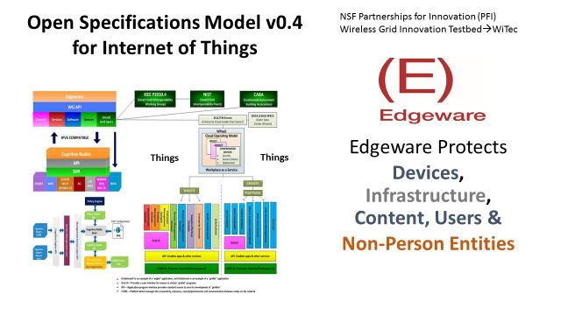
“Nothing exists in the physical world or in the virtual world, or can exist in either, that is not in the model.” Lee W McKnight, Syracuse University, 2014
A comprehensive model does not of course ensure a viable solution for resilient cities. However, if one is beginning a journey without a map, how can one know if we are there yet? WiTec coordinates the ongoing development of the Open Specifications Model for the wireless grid in Internet of Things (now v0.4; see above) to enable resilient cities, communities, and nations. WiTec also cooperates with the The Things Network, which has grown rapidly to include over 280 (increasingly smart) cities in over 60 nations. The Things Network leverages the LoRaWAN (Long Range Wide Area Network) wireless data network standard for secure peer-to-peer IoT innovation.
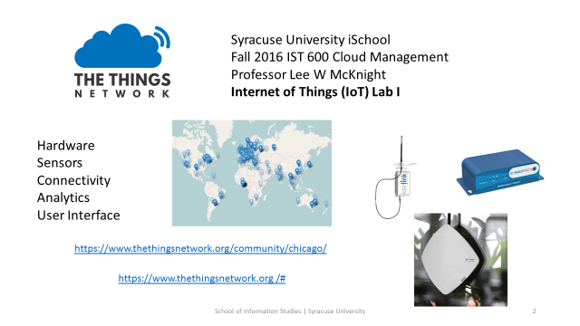
However, even in the most resilient cities and nations, events occur, due to extreme weather or other causes. The NSF PFI WiGiT project developed and tested on – and – off-grid dynamic edgeware solutions of cloud services, software defined (cognitive) radio, mesh networks, and other things for cyber physically secure social emergency response. WiTec, DRC ministries, and schools in Goma (city of 2 million near an active volcano) are planning Open Specs Model-compliant smart pack field tests, for worst-case scenario survival. WiTec invites the Interagency Task Force and Advisory Group and its partners to contribute to further evolution of the model, and edgeware, for the Democratic Republic of Congo and neighboring nations.
Near- and long-term OPEN primary/secondary education programs will focus on infrastructure applications - sustainable agriculture/forestry, water, waste water treatment, renewable energy systems, Internet futures, ecotourism, etc. With a focus on Internet of Things (IoT) sensor development for STEM applications applied to community needs, GIS Geodesign mapping for community and resource planning and management, DRC students will be well-trained for local infrastructure workforce and full participation in the Internet-drivent global economy.
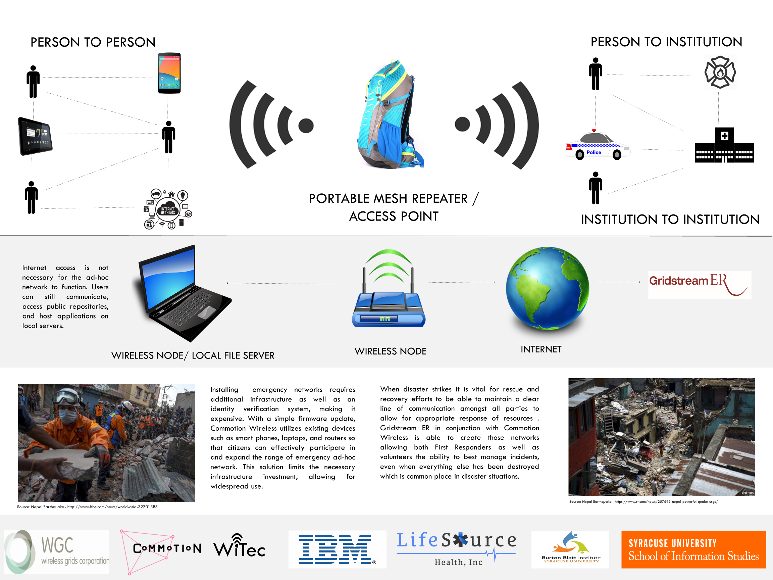
Source: UNICEF ‘In Case of Emergency’ event, Google San Francisco, March 2016
Inquiries: Lee W McKnight, faculty advisor, WiTec lmcknigh@syr.edu& Josephine Bellon, President, WiTec; jnbellon@syr.edu
This work will leverage advanced cloud infrastructure and services such as those offered by VMware. These have the benefit of facilitating regulatory compliance as well as enhancing cost-effective access for firms and governments, as the figure below illustrates.
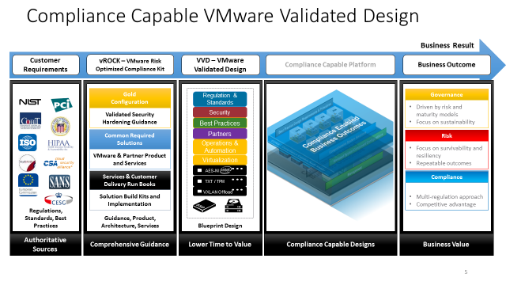
All D.R.C. Ministries have need for improved Internet access, and are invited to join. By aggregating demand private sector service providers and investors will have more confidence to support the effort. By doing so in innovation zones where barriers to new investment have been removed first, a positive example for the entire nation can be made. We propose that in cooperation with the Goma Volcano Observatory (OVG), Virunga National Park, the City of Goma, and its Provincial Governor, One Planet Education Network (OPEN), Congo Entrepreneurship Gate (CEG), and other Interagency Task Force and Advisory Group partners, the entire district be designated an emergency communication and broadband infrastructure innovation zone.
If there is interest and support, the Syracuse University Worldwide Innovation Technology and Entrepreneurship Club and commercial partners can begin work here immediately.
From Goma to D.R.C Broadband Vision 30 in 2020: How to Get There from Here
Even as the DRC localized educational programs described above are being developed and implemented, preparations for attaining the 30 in 2020 goal can begin. Some of the technologies to be adapted to the D.R.C. after being introduced to students for emergency preparedness may meet the needs of communities for off-grid communications when infrastructure is unavailable (creating infrastructure less wireless networks).
Admittedly, it is preferable and performance can be higher if advanced cloud, fiber, wireless, solar and electrical grid infrastructure is installed. For investors to make the 30 in 2020 achievable, it is likely that both new spectrum resources, both licensed and unlicensed, may be needed by market participants. Mobile backhaul and fronthaul demands of advanced services may necessitate extending fiber networks. Those may in turn motivate utility investors to co-invest in the Vision. Where possible, by sharing investment in these core Internet infrastructure elements, other firms such as Facebook will be motivated to co-invest themselves, as they are doing in neighboring nations such as Uganda.
With public agencies and schools confirming their intent to be Internet-accessible, private sector investors may have further incentive to co-invest themselves. After these conditions are confirmed, the Interagency Task Force may be authorized to accelerate allocation of spectrum, designation of Rights of Way, and authorization of utility infrastructure upgrades.

Schedule
April 2017 | September 2017 | April 2018 | September 2018 | 2019 | 2020
Begin public debate & inter-agency consulta-tion with Advisory Group on  BroadbandDRCVision | First Innovation Zone Provinces Identified  Off-grid Internet backpacks/hotspots/mesh networks available immediately to schools, government and industry | Spectrum licensed; regulations waived or reformed; municipal codes modified; incumbent operators and international partners new investments; solar energy and utilities expansion coordinated with broadband Internet infrastructure | Advanced infrastructure build-out and sharing underway; new entrants, incumbents, partners and utilities investing and sharing resources  4G & Beyond services available in City Centers in Innovation Zone Provinces | Access to Advanced Broadband Internet Services expands beyond initial major city deployments to neighboring communities.  Success in the 1-4 Innovation Zone Provinces leads to expansion to additional Provinces | Access to Advanced Broadband Internet Services extends to smaller communities with on- and off-grid solutions, solar power, and growth in access nationwide.
4% |  | 6% | 10% | 20% | 30%

Interagency Task Force Member Agencies
DRC Ministry of Planning: Mr. Wilfred Mushagalusa
DRC Ministry of Education: Mr. Didier Ekwi
DRC Ministry of Telecommunications (to be invited)
Governor of North Kivu (to be invited)
Governor of South Kivu (to be invited)
Governor of Kinshasa (invited)

Advisory Group Members
Eric Bidong, Co-coordinator, IATAG, Congo Entrepreneurship Gate (CEG), DRC
Jackin Bien-Aime, WGC
Dr. Katcho Karume, Director, Goma Volcano Observatory (OVG), DRC
Arsene Tungali, Co-coordinator, Executive Director Rudi International, DRC; also, Co-coordinator at Civil Society Internet Governance Caucus, IGC
George Newman, One Planet Education Network (OPEN)
Dr. Wednaud Ronelus – OPEN
Dr. Shirley Smith – OPEN
Ellen Baldwin – OPEN
Betto Jones, Central African Republic & Syracuse University Maxwell School
Mike Nelson, Cloudflare (invited)
Jim Gale - former US National Park Educator/Interpreter
Robert Cohen, Economic Strategy Institute
ESRI (For now through Dr. Karume – Goma Volcano Observatory)
Andreas Kuehn, East-West Institute (to be invited)
Robert Pepper, Facebook (to be invited)
Fiscal Development
Vint Cerf, Google (to be invited)
Tim Kelly, WGC &Lifesource Health
IBM (to be invited)
Microsoft (partly there)
Orange (to be invited)
South Africa Telecom (to be invited)
Dr. Lee McKnight, Peter Menaker, Wan Zhou, Jaime Gelberg, Syracuse University – School of Information Studies (iSchool) faculty and students
Johan Stokking, Wienke Griezman, The Things Network (invited)
UNESCO (to be invited ex officio)
World Bank (to be invited ex officio)
African Development Bank (to be invited ex officio)
VMWare (to be invited)
Yihan Yu, Oleksy, Syracuse iSchool Worldwide Innovation Technology and Entrepreneurship Club (WiTec)
** This text includes information and figures previously published by Lee W McKnight and colleagues (Syracuse University), and are used with his permission. The views expressed in this document are those of the authors in their individual capacity, and do not represent the views of Syracuse University.

Sources:
http://cybersummit.info/sites/cybersummit.info/files/book2017.pdf
http://www.economist.com/news/business/21718532-electric-vehicles-and-batteries-are-expected-create-huge-demand-copper-and-cobalt-mining?zid=304&ah=e5690753dc78ce91909083042ad12e30
https://www.technologyreview.com/s/603814/these-toaster-oven-size-radios-will-help-bring-5g-to-life/?set=603835
https://www.wsj.com/articles/congolese-violence-escalates-despite-deal-on-political-transition-1488537000
https://www.nytimes.com/2017/02/10/world/africa/african-nations-increasingly-silence-internet-to-stem-protests.html?hp&action=click&pgtype=Homepage&clickSource=story-heading&module=first-column-region&region=top-news&WT.nav=top-news
http://www.forbescustom.com/EmergingMarketsPgs/DRCongoP1.html
http://www.bbc.com/news/world-africa-13286306
http://www.indexmundi.com/democratic_republic_of_the_congo/life_expectancy_at_birth.html
https://www.ruralpovertyportal.org/en/country/statistics/tags/congo
http://www.allisps.com/en/offers/CONGO
http://www.cima.ned.org/blog/recent-protests-democratic-republic-congo-tell-us-state-internet-access-country/
http://www.internetworldstats.com/stats1.htm
http://allafrica.com/stories/201702020136.html
http://www.translationdirectory.com/articles/article1683.php
http://en.actualitix.com/country/cod/statistics-presentation-democratic-republic-of-the-congo.php
https://code.facebook.com/posts/1642803246023947/airtel-and-bcs-with-support-from-facebook-to-build-shared-fiber-backhaul-connectivity-in-uganda/
https://www.researchgate.net/publication/274754770_Open_Specifications_Model_v03_Wireless_Grids_Internet_of_Things_Technical_Requirements
http://iaesjournal.com/online/index.php/IJ-CLOSER/article/view/790
https://www.researchgate.net/publication/224221227_Interoperability_by_'Edgeware'_Wireless_Grids_for_Emergency_Response

