Liaison Statement

Liaison Statement Title: | LS from GSMA NEST for mapping with slices of different domains via Cross-domain OAM coordination
Security Classification: | Non-Confidential

Source Meeting Information
Meeting Number | Meeting Date | Meeting Location
Future Networks Programme – Network Slicing Taskforce meeting #93 | 25 March 2020 | Conference call

Document Details
Document Number: | Creation Date: | Document Author:
GSMA Future Networks Programme - Network Slicing Taskforce | 25 March 2020 | GSMA Future Networks Programme - Network Slicing Taskforce
Originating GSMA Source: | Deadline for response: | Liaison Statement Contact
 | - | GSMALiaisons@gsma.com  azad7.singh@ril.com

Action Required by Recipient
Internal Recipients:
External Recipients: | TO: IETF TEAS WG  CC: ETSI ZSM and 3GPP SA5

Introduction
The GSMA, one of the Market Representation Partners of 3GPP, have a project concerning End to end Network Slicing under the Future Networks Programme. The GSMA NEST in the Future Networks Programme aims to identify potential gaps in standards and input recommendations to related external bodies toward the realization of Network Slicing architecture designed from an End-to-End (E2E) perspective, spanning over different technical domains (e.g., device, access network, core network, transport network and network management system) in order to provide guaranteed Service Level Agreement based on customers’ requirements in the E2E manner. The group plans to complete the work by February 2021. Until then, identified gaps and recommendations will be sent to Standards Developing Organizations and Open Source Projects as soon as agreed by the group.

Discussion
In order to provide Service Level Agreement, usage of transport network is important in the context of path control and SLA assurance. Identifier of 3GPP network slice is S-NSSAI, while on transport network level there can be DSCP, VLAN tag, MPLS label, and so on.
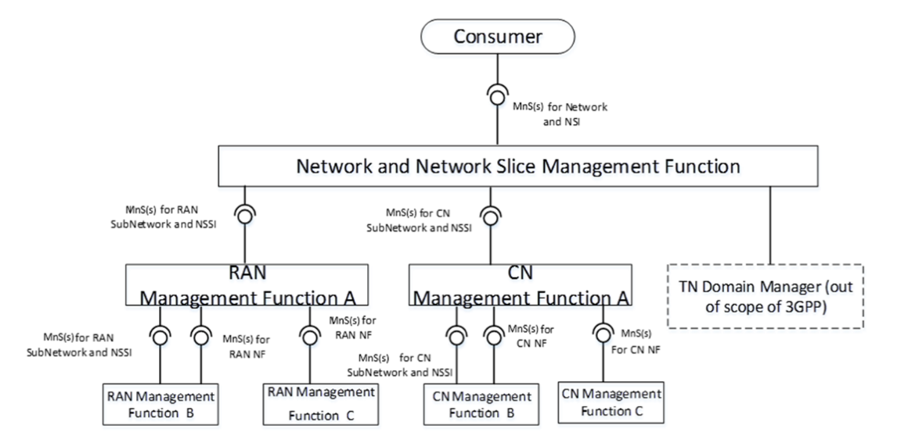
Based on the group’s goal which is to realize the E2E slice over cross-domains, the GSMA has not seen a solution on how to map S-NSSAI such that the manager of each domain identifies the corresponding transport network of the E2E network slice. In particular, Transport Network Domain Manager (TN Domain Manager) in Figure 1, which is expected to have a capability to manage the transport domain of the E2E network slice, in the context of SLA assurance, and an interface with 3GPP Network Slice Subnet Management Function (NSSMF), it does not seem to be defined.
Figure 1: An example of deployment scenario for management
(cf. 3GPP TS 28.533 V16.2.0 Figure A.8.1)

Action
GSMA NEST kindly requests IETF to take the above into consideration and to provide a solution of the TN Domain Manager.

Next Meetings
NGVT #1 06-May 2020
NGVT #2 20-May 2020
NGVT #3 03-Jun 2020
NGVT #4 17-Jun 2020
NGVT #5 01-Jul 2020

